Congo, Rep.

## Political Stability Estimate Data

The data set shows the political stability estimate of the country each year.

## # A tibble: 19 x 5  
## country iso3c date stability stabilityCategory4   
## <chr> <chr> <dbl> <dbl> <chr>   
## 1 Congo, Rep. COG 1996 -1.22 highly unstable   
## 2 Congo, Rep. COG 1998 -1.50 highly unstable   
## 3 Congo, Rep. COG 2000 -0.920 moderately unstable  
## 4 Congo, Rep. COG 2002 -1.58 highly unstable   
## 5 Congo, Rep. COG 2003 -1.17 highly unstable   
## 6 Congo, Rep. COG 2004 -1.19 highly unstable   
## 7 Congo, Rep. COG 2005 -1.17 highly unstable   
## 8 Congo, Rep. COG 2006 -0.924 moderately unstable  
## 9 Congo, Rep. COG 2007 -0.770 moderately unstable  
## 10 Congo, Rep. COG 2008 -0.720 moderately unstable  
## 11 Congo, Rep. COG 2009 -0.250 moderately unstable  
## 12 Congo, Rep. COG 2010 -0.316 moderately unstable  
## 13 Congo, Rep. COG 2011 -0.354 moderately unstable  
## 14 Congo, Rep. COG 2012 -0.490 moderately unstable  
## 15 Congo, Rep. COG 2013 -0.475 moderately unstable  
## 16 Congo, Rep. COG 2014 -0.359 moderately unstable  
## 17 Congo, Rep. COG 2015 -0.526 moderately unstable  
## 18 Congo, Rep. COG 2016 -0.519 moderately unstable  
## 19 Congo, Rep. COG 2017 -0.527 moderately unstable

## Political Stability Estimate Plot

The plot shows the trends of stabilization and destabilization for the each country.

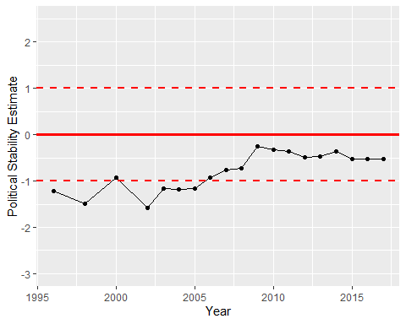

Political Stability Trend